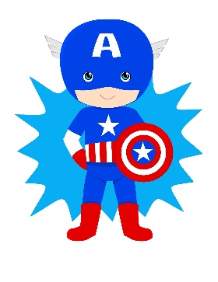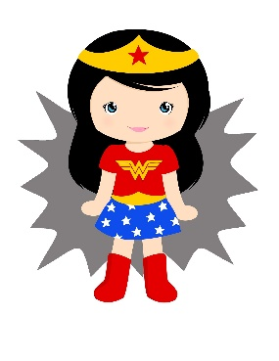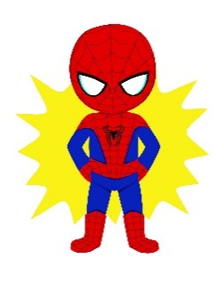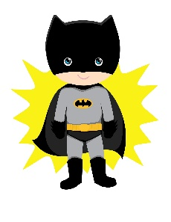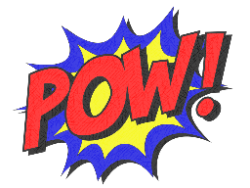

Harley Quinn loves Joker.

Kryptonite reduces Superman’s powers.

Wonder Woman wasn’t killed.

Metropolis is protected by Superman

Thor drinks a mug of coffee.

Iron Man built his armor yesterday.

Move 2 spaces back.

**START**

**FINISH**

He reads   
a comic book.

Spiderman watched TV now.

The map was lost by Iron Man.

They save the world every day.

Move 3 spaces forward.

Captain America carries a shield.

Batman’s parents were   
killed.

The Flash has broken speed of light.

Charles  
 Xavier formed   
X-men   
team.

Bow is being used by Green Arrow.

Hawkeye was being controlled by Loki.

Mjolnir was destroyed by Hela.

Winter Soldier was brainwashed by Hydra.

Professor X uses telepathy.

Miss

a turn.

Roll a dice again.

Move 2 spaces forward.

Move 4 spaces back.

Miss

a turn.

Move 4 spaces back.

Move 3 spaces back.

Roll a dice again.

Captain America visited Peggy Carter.

Wakanda population saw Black Panther.

Infinity Stones are being sought by Thanos.

Black   
Widow has never helped Batman.

Iron Man doesn’t water Groot.

Star-Lord is listening to an Awesome Mix Vol 1.

The villain was arrested by Superman.

Scientists have shrunk   
Ant-Man.

The Avengers were recruited by Nick Fury .

Tesseract was stolen by Loki.

Terrorists have kidnapped Tony Stark.

Wonder Woman is wearing a tiara.

Captain America didn’t kill his best friend.

Mary Jane was kissed by Spiderman.

Marvel created The Avengers

Spiderman was being looked after by Aunt May.

Batmobile   
is being driven by Batman.

Lex Luthor was defeated by Superman.

Scarlet   
Witch uses magic.

Black   
Widow was orphaned by her parents.

Wakanda

hid Vibranium

Wonder Woman wears a skirt.

Captain America wasn’t trusterd by Iron Man.

**Superheroes - passive voice**