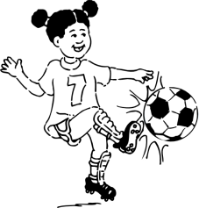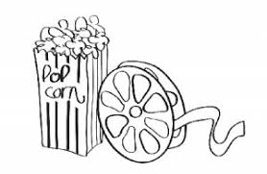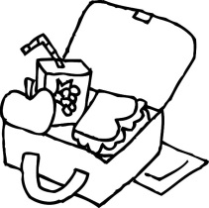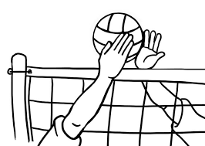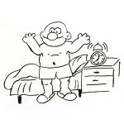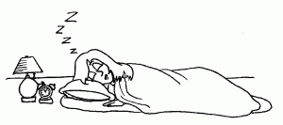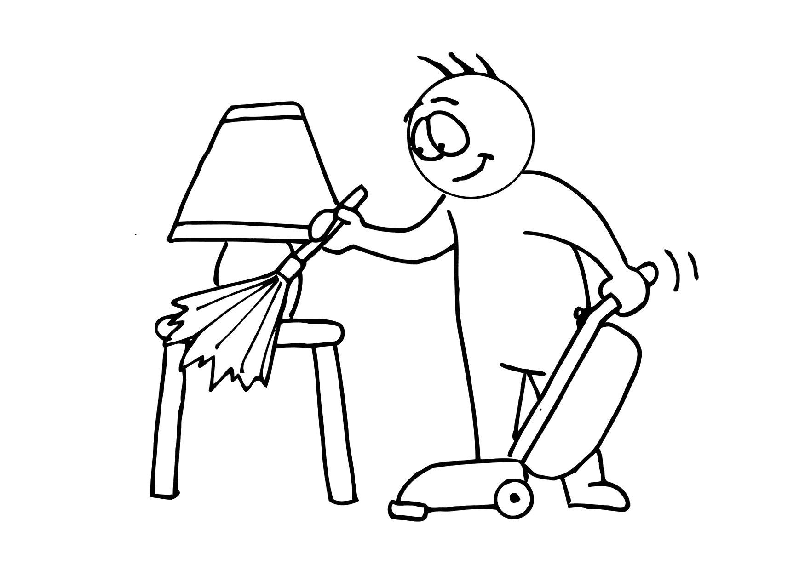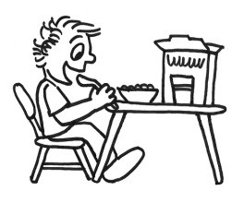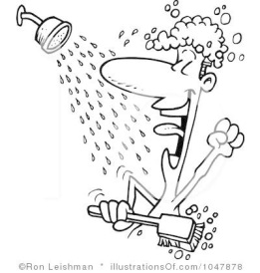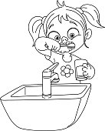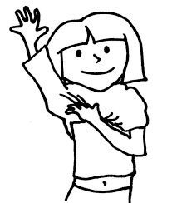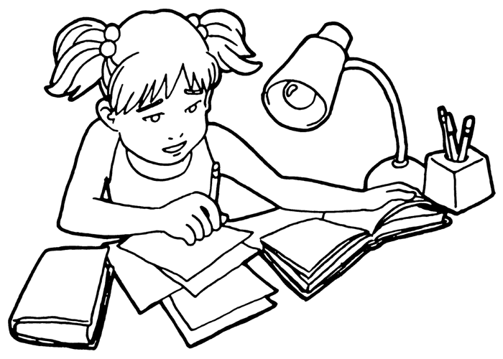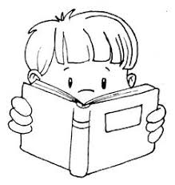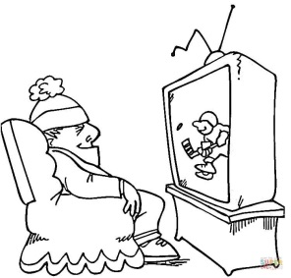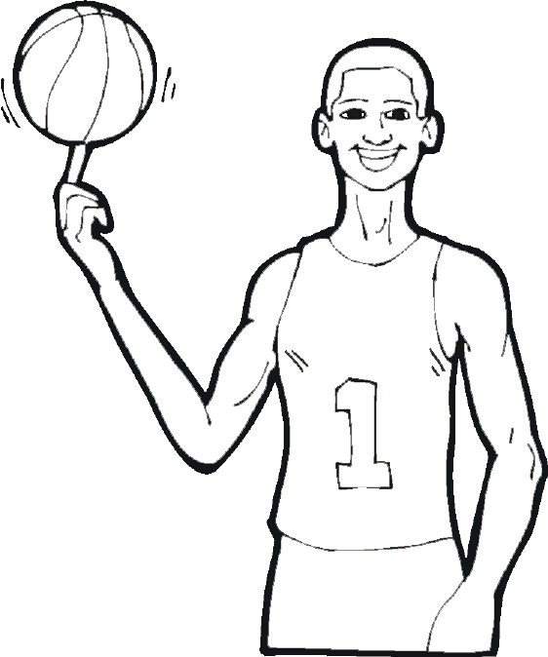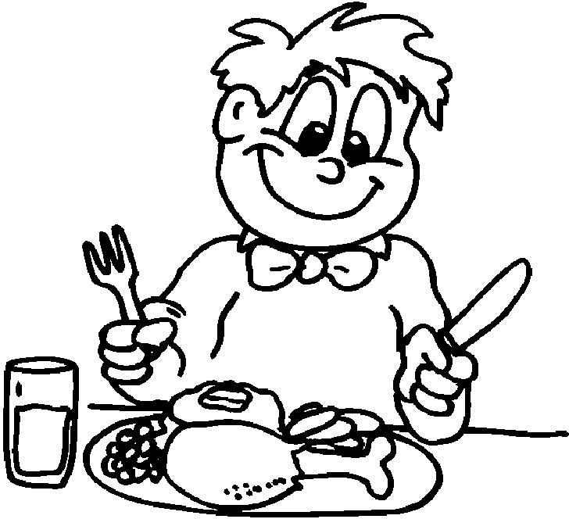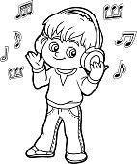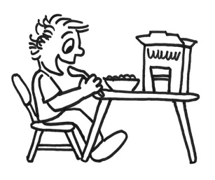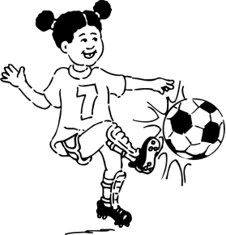__

tidy (your) room __

have a shower __

have lunch __

have dinner __

have breakfast __

get dressed __

play basketball __

play volleyball __

play computer games __

watch TV __

read a book __

get up __

go to the cinema __

go to bed/sleep __

brush (your) teeth __

do homework __

listen to music__

play football __

tidy (your) room __

have a shower __

have lunch __

have dinner __

have breakfast __

get dressed __

play basketball __

play volleyball __

play computer games __

watch TV __

read a book __

get up __

go to the cinema __

go to bed/sleep __

brush (your) teeth __

do homework __

listen to music__

play football __

**18**

**17**

**17**

**16**

**15**

**14**

**13**

**12**

**11**

**10**

**9**

**7**

**6**

**5**

**4**

**3**

**2**

**1**

**8**

**10**

**6**

**3**

ACTIVITIES

**4**

**5**

**8**

**7**

**11**

**14**

**15**

**16**

**18**

**13**

**12**

**9**

**2**

**1**

ACTIVITIES